**CHAPTER 1**

# INTRODUCTION

The Obstacle avoidance robotics is used for detecting obstacles and avoiding the collision. This is an autonomous robot. The design of Obstacle avoidance robot requires the integration of many sensors according to their task.

The Obstacle detection is the primary requirement of this autonomous robot.The robot gets the information from surrounding area through mounted sensors on the robot.Some sensing devices like infrared sensors,bump sensors,ultrasonic sensor etc.Ultrasonic sensor is most suitable for obstacle detection and it is of low cost and as hidh ranging capability.The motors are connected through motor driver IC to micro controller.The ultrasonic sensor is attached infront of robot.

Arduino is the main processing unit of the robot. Out of the 14 available digital I/O pins, 6 pins are used in this project design.The ultrasonic sensor has 4 pins: Vcc, Trig, Echo and Gnd. Vcc and Gnd are connected to the supply pins of the Arduino. Trig is connected to the 11th pin and Echo is connected to 10th pin of the Arduino.L293D is a 16 pin IC. Pins 1 and 9 are enable pins. They are connected to Vcc. Pins 2 and 7 are control inputs from microcontroller for first motor. They are connected to pins 9 and 8 of Arduino respectively.Similarly, pins 10 and 15 are control inputs from microcontroller for second motor. They are connected to pins 4 and 3 of Arduino. Pins 4, 5, 12 and 13 of L293D are ground pins and are connected to Gnd.First motor

(consider this as the motor for left wheel) is connected across the pins 3 and 6 of L293D. The second motor, which acts as the right wheel motor, is connected to 11 and 14 pins of L293D.The 16th pin of L293D is Vcc1. This is connected to 5V Vcc. The 8th pins is Vcc2. This is the motor supply voltage. This can be connected anywhere between 4.7V and 36V. In this project, pin 8 if L293D is connected to 9V supply.Motor Driver boards are available with on – board 5V voltage regulator. A similar one is used in the project.

## 1.1 PROBLEM DEFINITION

Robotics is the branch of technology that deals with the design, construction, operation, and application of robots. A machine capable of carrying out a complex series of actions automatically, esp. one programmable by a computers is defined as a robot. The project is to develop a robot that will move according to the code assigned but find a free space, navigating from any obstacle on its way. This kind of obstacle is very useful in industries where automatic supervision is needed, for example, in places where it might be risky for humans to be. This robot can also be made by putting other sensors like light sensors or line sensors, ultrasonic sensors and ultrasound sensor depending on the need.

**CHAPTER 2**

# SOFTWARE REQUIREMENTS

|  |
| --- |
| **2.1 ARDUINO SOFTWARE IDE**    Figure 2.1 Screenshot of the Arduino IDE |
| **Developer(s)** Arduino Software |
|  |
| **Repository** github.com/arduino/Arduino |
| **Written in** Java, C, C++ |
| **Operating system** Windows, macOS, Linux |
| **Platform** IA-32, x86-64, ARM |
| **Type** Integrated development environment |
|  |
| **Website** arduino.cc |

## Table 2.1 description of software

A program for Arduino may be written in any [programming language](https://en.m.wikipedia.org/wiki/Programming_language) for a compiler that produces binary machine code for the target processor. Atmel provides a development environment for their microcontrollers, AVR Studio and the newer Atmel Studio.

The Arduino project provides the Arduino [integrated development environment](https://en.m.wikipedia.org/wiki/Integrated_development_environment) (IDE), which is a [cross-platform](https://en.m.wikipedia.org/wiki/Cross-platform) application written in the programming language [Java.](https://en.m.wikipedia.org/wiki/Java_(programming_language)) It originated from the IDE for the languages [Processing](https://en.m.wikipedia.org/wiki/Processing_(programming_language)) and [Wiring.](https://en.m.wikipedia.org/wiki/Wiring_(development_platform)) It includes a code editor with features such as text cutting and pasting, searching and replacing text, automatic indenting, [brace matching,](https://en.m.wikipedia.org/wiki/Brace_matching) and [syntax highlighting,](https://en.m.wikipedia.org/wiki/Syntax_highlighting) and provides simple one-click mechanisms to compile and upload programs to an Arduino board. It also contains a message area, a text console, a toolbar with buttons for common functions and a hierarchy of operation menus.

A program written with the IDE for Arduino is called a sketch. Sketches are saved on the development computer as text files with the file extension .ino. Arduino Software (IDE) pre-1.0 saved sketches with the extension .pde.

The Arduino IDE supports the languages [C](https://en.m.wikipedia.org/wiki/C_(programming_language)) and [C++](https://en.m.wikipedia.org/wiki/C%2B%2B) using special rules of code structuring. The Arduino IDE supplies a [software library](https://en.m.wikipedia.org/wiki/Software_library) from the [Wiring](https://en.m.wikipedia.org/wiki/Wiring_(development_platform)) project, which provides many common input and output procedures. User-written code only requires two basic functions, for starting the sketch and the main program loop, that are compiled and linked with a program stub main() into an executable [cyclic executive](https://en.m.wikipedia.org/wiki/Cyclic_executive) program with the [GNU toolchain,](https://en.m.wikipedia.org/wiki/GNU_toolchain) also included with the IDE distribution. The Arduino IDE employs the program avrdude to convert the executable code into a text file in hexadecimal encoding that is loaded into the Arduino board by a loader program in the board's firmware.

## 2.2 PROGRAMMING

The Arduino/Genauino Uno can be programmed with the ([Arduino](https://www.arduino.cc/en/Main/Software)

[Software](https://www.arduino.cc/en/Main/Software) (IDE)). Select "Arduino/Genuino Uno from the Tools > Board menu (according to the microcontroller on your board). For details, see the [reference](https://www.arduino.cc/en/Reference/HomePage) and[tutorials.](https://www.arduino.cc/en/Tutorial/HomePage)

The ATmega328 on the Arduino/Genuino Uno comes preprogrammed with a [bootloader](https://www.arduino.cc/en/Hacking/Bootloader?from=Tutorial.Bootloader) that allows you to upload new code to it without the use of an external hardware programmer. It communicates using the original STK500 protocol

[(reference,](http://www.atmel.com/Images/doc2525.pdf) [C header files)](http://www.atmel.com/dyn/resources/prod_documents/avr061.zip).

You can also bypass the bootloader and program the microcontroller through the ICSP (In-Circuit Serial Programming) header using[Arduino ISP](https://www.arduino.cc/en/Main/ArduinoISP) or similar; see [these instructions](https://www.arduino.cc/en/Hacking/Programmer) for details.The ATmega16U2 (or 8U2 in the rev1 and rev2 boards) firmware source code is available in the Arduino repository. The ATmega16U2/8U2 is loaded with a DFU bootloader, which can be activated by:

* On Rev1 boards: connecting the solder jumper on the back of the board (near the map of Italy) and then rese ing the 8U2.
* On Rev2 or later boards: there is a resistor that pulling the 8U2/16U2 HWB line to ground, making it easier to put into DFU mode.

You can then use [Atmel's FLIP software(](http://www.atmel.com/products/microcontrollers/default.aspx)Windows) or the [DFU programmer](http://dfu-programmer.github.io/) (Mac OS X and Linux) to load a new firmware. Or you can use the ISP header with an external programmer (overwriting the DFU bootloader). See [this usercontributed tutorial](http://forum.arduino.cc/index.php/topic,111.0.html) for more information.

## 2.3 SAMPLE PROGRAM FOR OBSTACLE AVOIDING ROBOT

#define echopin 8

#define trigpin 9 int maximumRange=30; long duration,distance; void setup() { Serial.begin(9600); pinMode(trigpin,OUTPUT); pinMode(echopin,INPUT); pinMode(4,OUTPUT); pinMode(5,OUTPUT); pinMode(13,OUTPUT); pinMode(6,OUTPUT); pinMode(7,OUTPUT);

} void loop() { {

digitalWrite(trigpin,LOW); delayMicroseconds(2); digitalWrite(trigpin,HIGH); delayMicroseconds(10); duration=pulseIn (echopin,HIGH); distance=duration/58.2; delay(50); Serial.println(distance); } if(distance>=30){ digitalWrite(4,HIGH); digitalWrite(5,HIGH); digitalWrite(6,LOW); digitalWrite(7,LOW); delay(200); }

else if(distance>=15&&distance<=25)

{ digitalWrite(4,HIGH); digitalWrite(5,LOW); digitalWrite(6,LOW); digitalWrite(7,LOW); delay(1000); } else if(distance<15) { digitalWrite(4,LOW); digitalWrite(5,LOW); digitalWrite(6,HIGH); digitalWrite(7,HIGH); delay(1000); digitalWrite(4,LOW); digitalWrite(5,HIGH); digitalWrite(6,LOW); digitalWrite(7,LOW); delay(1000); }}

**CHAPTER 3**

# EXISTING SYSTEM

We reviewed different obstacle detecting robot mechanisms that have been built by a lot of students and other practitioners that are in existance.

Obstacle detection and avoidance in a real world environment - that appears so easy to humans is a rather difficult task for autonomous mobile robots and is still a well-researched topic in robotics. In many previous works, a wide range of sensors and various methods for detecting and avoiding obstacles for mobile robot purpose have been proposed. Good references related to the developed sensor systems and proposed detection and avoidance algorithms can be found.

Based on these developed sensor systems, various approaches related to this work can be grouped into two categories.

The first one tends to use ultrasonic sensors for their simple implementation and fast obstacle detection, but they show great accuracy and reliability limits when it comes to detect obstacles having 3-dimensions.

On the other hand, we have the vision-based sensor systems,which can be divided into two subgroups of sensor systems:

1. stereo vision
2. laser range sensors.

The former one applies with good reliability to the detection of3-Dimensional objects but reveals to be deficient in term of speed and towards weakly textured obstacles The latter one, when applied as an horizontally emitted laser range sensor is efficient only towards 2-Dimensional obstacles.

We have also,2-Dimensional laser range finder sensor which can efficiently detect 3-Dimensional obstacles but is poorly characterized in real-time detection. We did a lot of research on the obstacle detecting robots .we also found many great articles and research papers on it.

One of the projects that we found ,was uploaded by a student that is given below:

he broke down the robot into 5 subsytems : Locomotion , Power , Sensors , Control, and Display.

1. Locomotion - uses two HS-42BB servos for locomotion and one ball caster
2. Power - four AA batteries will provide the power for all the systems
3. Sensors - five QRB1113 reflective object sensors will track the line , one scanning PING ultrasonic sensor will provide ranging, and one photo resistor /LED will search for victims.
4. Control - One PIC 16F616 microcontroller will act as the brains for the robot . It will be programmed in PICBASIC and assembly
5. Display - one LCD display will show what routine is being done , one LED will show power , and one LED will flash when a victim is detected.

For an autonomous mobile robot performing a navigation-based task in a vague environment, to detect and to avoid encountered obstacles is an important issue and a key function for the robot body safety as well as for the task continuity.

**CHAPTER 4**

# PROPOSED SYSTEMS

This chapter deals with the proposed system**.** The Obstacle avoidance robotics is used for detecting obstacles and avoiding the collision.This is an autonomous robot.The design of Obstacle avoidance robot requires the integration of many sensors according to their task.

## 4.1 ARCHIETECTURE

### 1.1.1 CIRCUIT DIAGRAM

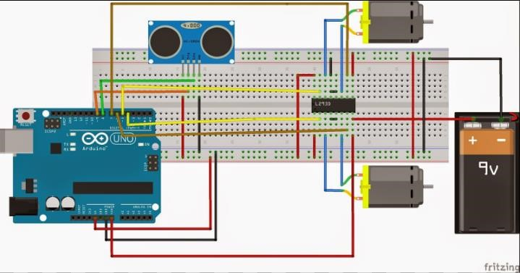

**Figure 4.1 Circuit diagram for obstacle avoiding robot**

### 4.1.2 EXPLANATION

* From ultrasonic sensor echo pin is given to 8th pin of arduino.
* Trig pin of sensor is given to 9th pin.
* 9v is given to Vcc of sensor.
* GND pin of sensor is grounded.
* 4th pin of arduino is given to the input A1 of motor driver.
* 5th pin of arduino is given to the input B1 of motor driver.
* 6th pin of arduino is given to the input A2 of motor driver.
* 7th pin of arduino is given to the input B2 of motor driver.
* GND pin of arduino is grounded.
* Output A1 and output A2 of motor driver is given to the 1st motor.
* Output B1 and output B2 of motor driver is given to the 2nd motor.
* Positive of 9v battery is connected to one end of bread board.
* Negative of 9v battery is connected to another end of bread board.
* Enable 1 of motor driver is connected to 9v battery.
* Enable 2 of motor driver is connected to 9v battery.
* Vss of motor driver is given 5v supply by connecting it to Vin of arduino.
* GND pins of motor driver are shorted and grounded in bread board.

**CHAPTER 5**

# SYSTEM DESIGN

## 5.1 BLOCK DIAGRAM

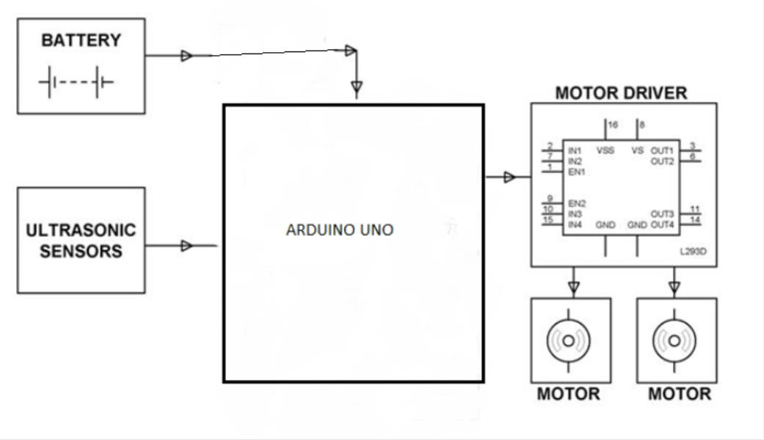

**Figure 5.1 Block diagram**

### 5.1.2 EXPLANATION

* The above block diagram consist of ultrasonic sensor,Arduino UNO,Motor driver L293D,Two DC Motors and a Battery.
* Using an external trigger signal, the Trig pin on ultrasonic sensor is made logic high.
* During this time, the ultrasonic sensor continuously calculate the distance between the robot and the reflective surface.
* Thus the ultrasonic sensor provides a digital input to the arduino board.
* By taking 9v supply from battery the arduino provides output to the Motor Driver which is connected to it.
* To this motor driver two motors are connected .
* When the robot is powered on, both the motors will run normally and moves forward.

**CHAPTER 6**

**MODULES**

# COMPONENTS USED

* Arduino Uno
* Ultrasonic Sensor – HC – SR04
* Motor Driver IC – L293D
* Dc Motors x 2
* Robot Chassis
* Bread board

## 6.1 ARDUINO UNO

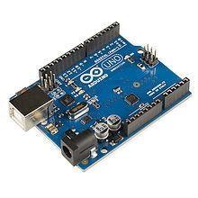

### Figure 6.1.1 Arduino UNO

|  |  |  |  |
| --- | --- | --- | --- |
| **Developer** | Arduino | | |
| **Manufacturer** | Many | | |
| **Type** | Single-board microcontroller | | |
| **Operating system** | | None |  |
| **CPU** | | Atmel AVR | (8-bit), |
|  | | ARM Cortex-M0+ | (32-bit), |
|  | | ARM Cortex-M3  Intel Quark (x86) (32-bit) | (32-bit), |
| **Memory** | | SRAM | |
| **Storage** | | Flash, EEPROM | |
| **Website** | | arduino.cc | |

### Table 6.1.1 Description of arduino

Arduino is an open source, computer hardware and software company, project, and user community that designs and manufactures [microcontroller](https://en.m.wikipedia.org/wiki/Microcontroller) kits for building digital devices and interactive objects that can sense and control objects in the physical world. The project's products are distributed as [open-source hardware](https://en.m.wikipedia.org/wiki/Open-source_hardware) and [software,](https://en.m.wikipedia.org/wiki/Open-source_software) which are licensed under the [GNU Lesser General Public License (](https://en.m.wikipedia.org/wiki/GNU_Lesser_General_Public_License)LGPL) or the [GNU General Public License](https://en.m.wikipedia.org/wiki/GNU_General_Public_License) (GPL), permitting the manufacture of Arduino boards and software distribution by anyone. Arduino boards are available commercially in preassembled form, or as [do-it-yourself](https://en.m.wikipedia.org/wiki/Do-it-yourself) kits.

Arduino board designs use a variety of microprocessors and controllers. The boards are equipped with sets of digital and analog [input/output](https://en.m.wikipedia.org/wiki/Input/output) (I/O) pins that may be interfaced to various expansion boards (shields) and other circuits. The boards feature serial communications interfaces, including [Universal Serial Bus](https://en.m.wikipedia.org/wiki/Universal_Serial_Bus) (USB) on some models, which are also used for loading programs from personal computers. The microcontrollers are typically programmed using a dialect of features from the programming languages [C](https://en.m.wikipedia.org/wiki/C_(programming_language)) and [C++.](https://en.m.wikipedia.org/wiki/C%2B%2B) In addition to using traditional compiler toolchains, the Arduino project provides an [integrated development environment](https://en.m.wikipedia.org/wiki/Integrated_development_environment) (IDE) based on the [Processing](https://en.m.wikipedia.org/wiki/Processing_(programming_language)) language project. Common examples of such devices intended for beginner hobbyists include simple [robots,](https://en.m.wikipedia.org/wiki/Robot) [thermostats,](https://en.m.wikipedia.org/wiki/Thermostat) and [motion detectors.](https://en.m.wikipedia.org/wiki/Motion_detector)

# 6.1.1DESCRIPTION OF BOARD

|  |  |
| --- | --- |
| Microcontroller | [ATmega328P](http://www.atmel.com/Images/Atmel-42735-8-bit-AVR-Microcontroller-ATmega328-328P_Datasheet.pdf) |
| Operating Voltage | 5V |
| Input Voltage (recommended) | 7-12V |
| Input Voltage (limit) | 6-20V |
| Digital I/O Pins | 14 (of which 6 provide PWM output) |
| PWM Digital I/O Pins | 6 |
| Analog Input Pins | 6 |
| DC Current per I/O Pin | 20 mA |
| DC Current for 3.3V Pin | 50 Ma |
| Flash Memory | 32 KB (ATmega328P)  of which 0.5 KB used by bootloader |
| SRAM | 2 KB (ATmega328P) |
| EEPROM | 1 KB (ATmega328P) |
| Clock Speed | 16 MHz |
| LED_BUILTIN | 13 |
| Length | 68.6 mm |
| Width | 53.4 mm |
| Weight | 25 g |

## Table 6.1.2 Technical specification of arduino

The description of the components on the board are as follows:

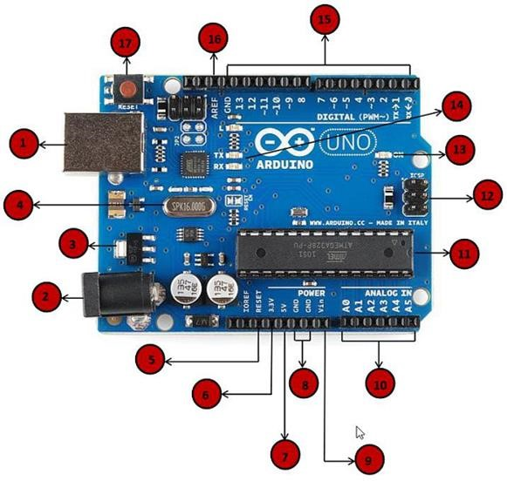

**Figure 6.1.2 Description of arduino board**

## 6.2 ULTRASONIC SENSOR

The ultrasonic sensor is used for obstacle detection. Ultrasonic sensor transmits the ultrasonic waves from its sensor head and again receives the ultrasonic waves reflected from an object.

There are many applications use ultrasonic sensors like instruction alarm systems, automatic door openers etc. The ultrasonic sensor is very compact and has a very high performance.

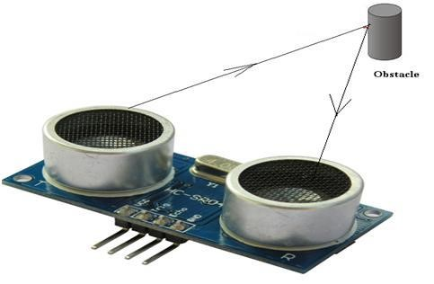

**Figure 6.2.1 Ultrasonic sensor**

### 6.2.1 WORKING PRINCIPLE

The ultrasonic sensor emits the short and high frequency signal. These propagate in the air at the velocity of sound. If they hit any object, then they reflect back echo signal to the sensor. The ultrasonic sensor consists of a multi vibrator, fixed to the base. The multi vibrator is combination of a resonator and vibrator. The resonator delivers ultrasonic wave generated by the vibration. The ultrasonic sensor actually consists of two parts; the emitter which produces a 40 kHz sound wave and detector detects 40 kHz sound wave and sends electrical signal back to the microcontroller.

**Figure 6.2.2**

**Working of ultrasonic sensor**

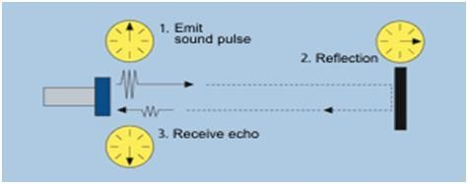

The ultrasonic sensor enables the robot to virtually see and recognize object, avoid obstacles, measure distance. The operating range of ultrasonic sensor is 10 cm to 30 cm.

### 6.2.2 OPERATION

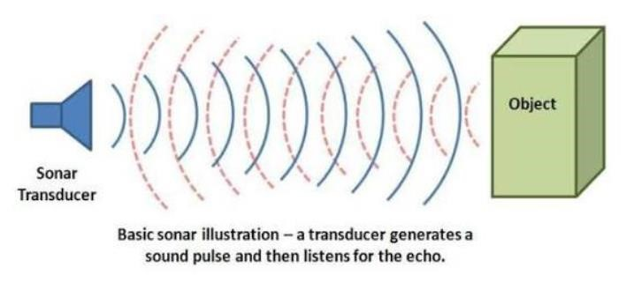

#### Figure 6.2.3 Sonar illustration

When an electrical pulse of high voltage is applied to the ultrasonic transducer it vibrates across a specific spectrum of frequencies and generates a burst of sound waves. Whenever any obstacle comes ahead of the ultrasonic sensor the sound waves will reflect back in the form of echo and generates an electric pulse. It calculates the time taken between sending sound waves and receiving echo. The echo patterns will be compared with the patterns of sound waves to determine detected signal’s condition.

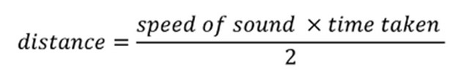

**Note:** The ultrasonic receiver shall detect signal from the ultrasonic transmitter while the transmit waves hit on the object. The combination of these two sensors will allow the robot to detect the object in its path. The ultrasonic sensor is attached in front of the robot and that sensor will also help the robot navigate through the hall of any building.

**6.2.3 APPLICATIONS OF ULTRASONIC SENSOR:**

* Automatic change over’s of traffic signals
* Intruder alarm system
* Counting instruments access switches parking meters
* Back sonar of automobiles

**6.2.4 FEATURES OF ULTRASONIC SENSOR:**

* Compact and light weight
* High sensitivity and high pressure
* High reliability
* Power consumption of 20mA
* Pulse in/out communication
* Narrow acceptance angle
* Provides exact, non-contact separation estimations within 2cm to 3m
* The explosion point LED shows estimations in advancement
* 3-pin header makes it simple to connect utilizing a servo development link

## 6.3 L293D MOTOR DRIVER

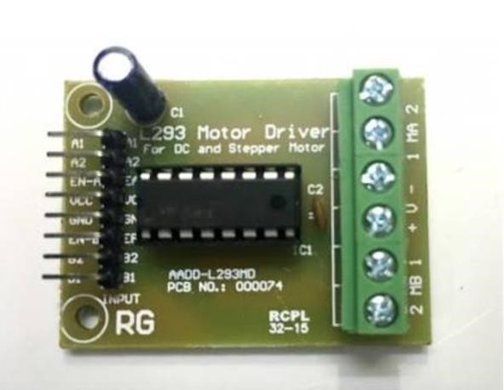

**Figure 6.3.1 L293D motor driver**

### 6.3.1 L293D DESCRIPTION

L293D is a typical Motor driver or Motor Driver IC which allows DC motor to drive on either direction. L293D is a 16-pin IC which can control a set of two DC motors simultaneously in any direction. It means that you can control two [DC motor](http://www.rakeshmondal.info/High-Torque-Motor-Low-RPM-Motor) with a single L293D IC. Dual H-bridge Motor Driver integrated circuit (IC).

The l293d can drive small and quiet big motors as well, check the Voltage Specification at the end of this page for more info.

You can Buy L293D IC in any electronic shop very easily and it costs around 70 Rupees (INR) or around 1 $ Dollar (approx Cost) or even lesser cost. You can find the necessary pin diagram, working, a circuit diagram, Logic description and Project as you read through.

### 6.3.2 CONCEPT

It works on the concept of H-bridge. H-bridge is a circuit which allows the voltage to be flown in either direction. As you know voltage need to change its direction for being able to rotate the motor in clockwise or anticlockwise direction, Hence H-bridge IC are ideal for driving a DC motor.

In a single L293D chip there are two h-Bridge circuit inside the IC which can rotate two dc motor independently. Due its size it is very much used in robotic application for controlling DC motors. Given below is the pin diagram of a L293D motor controller. There are two Enable pins on l293d. Pin 1 and pin 9, for being able to drive the motor, the pin 1 and 9 need to be high. For driving the motor with left H-bridge you need to enable pin 1 to high. And for right H-Bridge you need to make the pin 9 to high. If anyone of the either pin1 or pin9 goes low then the motor in the corresponding section will suspend working. It’s like a switch.

**TIP:** you can simply connect the pin16 VCC (5v) to pin 1 and pin 9 to make them high.

Here is a table describing the control pin functions.

|  |  |  |  |
| --- | --- | --- | --- |
| **ENABLE** | **DIRA** | **DIRB** | **Function** |
| H | H | L | Turn right |
| H | L H | | Turn left |
| H | L/H | L/H | Fast stop |
| L | either | Either | Slow stop |

#### Table 6.3.1 control pin functions of motor driver

**6.3.3 L293D PIN DIAGRAM:**

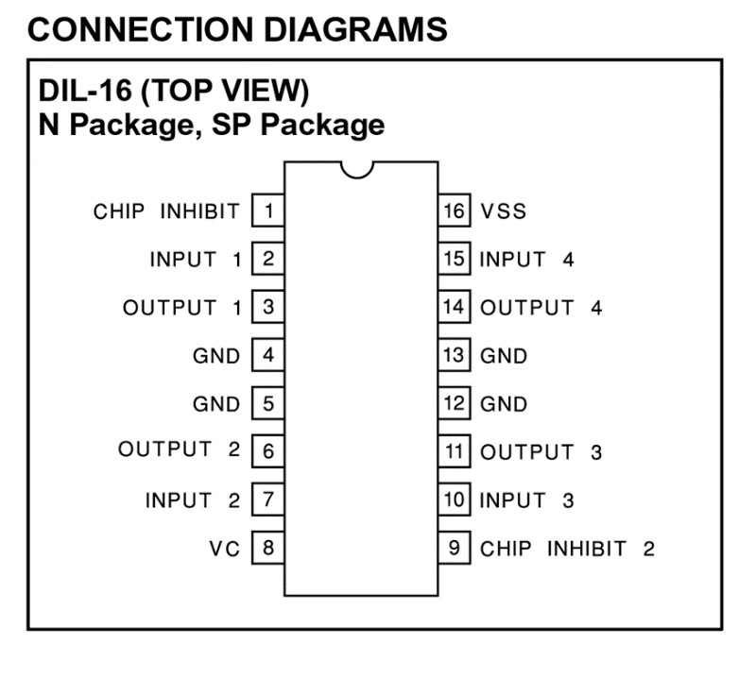

**Figure 6.3.2 L293D pin diagram**

### 6.3.4 WORKING OF L293D

There are 4 input pins for l293d, pin 2,7 on the left and pin 15 ,10 on the right as shown on the pin diagram. Left input pins will regulate the rotation of motor connected across left side and right input for motor on the right hand side. The motors are rotated on the basis of the inputs provided across the input pins as LOGIC 0 or LOGIC 1.In simple you need to provide Logic 0 or 1 across the input pins for rotating the motor.

### 6.3.5 L293D LOGIC TABLE

Lets consider a Motor connected on left side output pins (pin 3,6). For rotating the motor in clockwise direction the input pins has to be provided with Logic 1 and Logic

0.

* **Pin 2** = **Logic 1** and **Pin 7** = **Logic 0** | Clockwise Direction
* **Pin 2** = **Logic 0** and **Pin 7** = **Logic 1** | Anticlockwise Direction
* **Pin 2** = **Logic 0** and **Pin 7** = **Logic 0** | Idle [No rotation] [Hi-Impedance state] • **Pin 2** = **Logic 1** and **Pin 7** = **Logic 1** | Idle [No rotation]

In a very similar way the motor can also operate across input pin 15,10 for motor on the right hand side.

### 6.3.6 CIRCUIT DIAGRAM

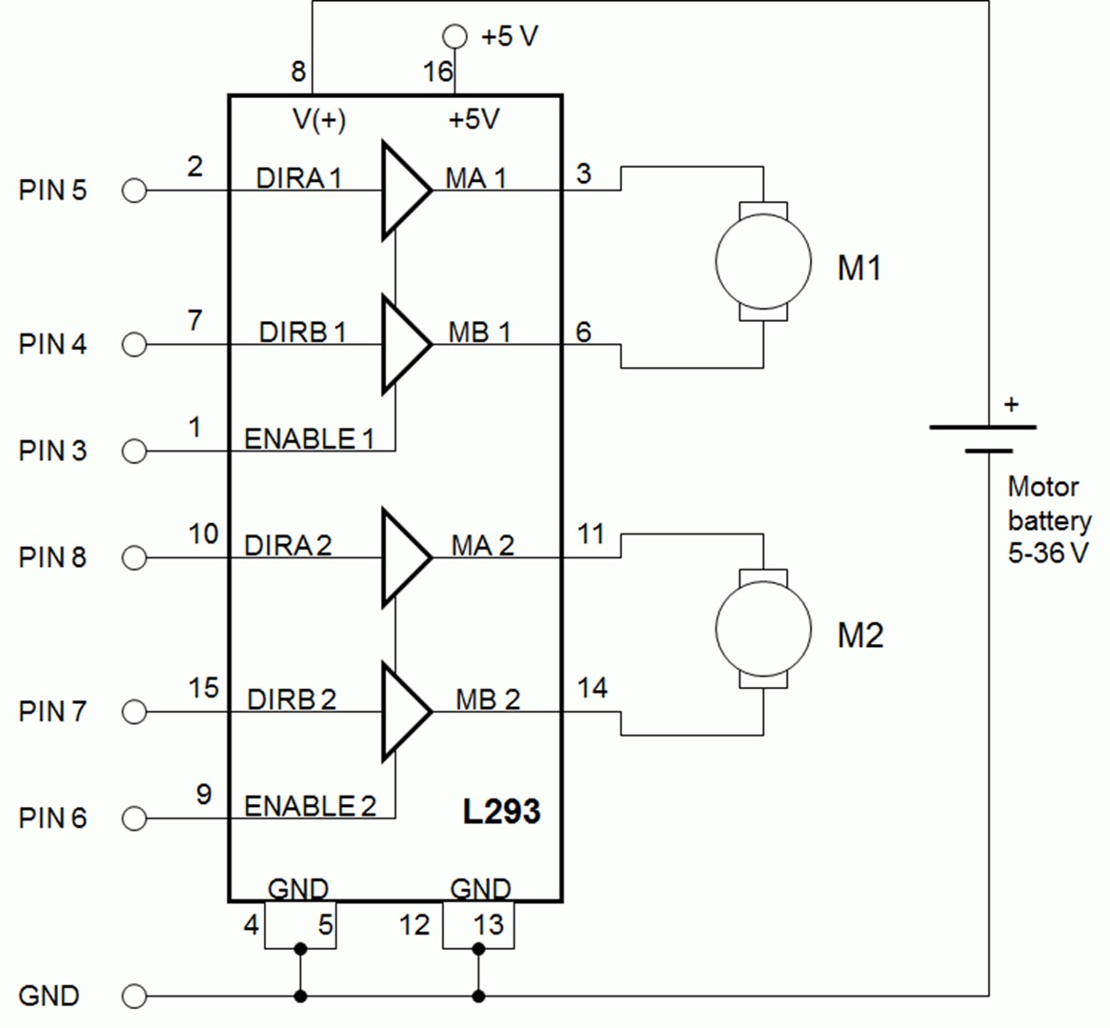

**Figure 6.3.3 Circuit Diagram For l293d motor driver IC controller.**

## 6.4 DC MOTOR

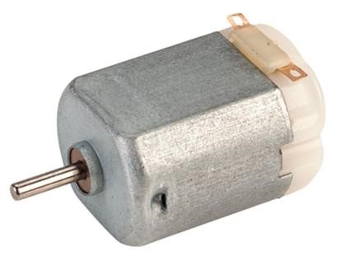

### Figure 6.4 DC motor

A motor is an electrical machine which converts electrical energy into mechanical energy. The principle of working of a DC motor is that "whenever a current carrying conductor is placed in a magnetic field, it experiences a mechanical force".D.C. machines are the electro mechanical energy converters which work from a d.c. source and generate mechanical power or convert mechanical power into a d.c. power. These machines can be broadly classified into two types, on the basis of their magnetic structure.

## 6.5 CHASSIS

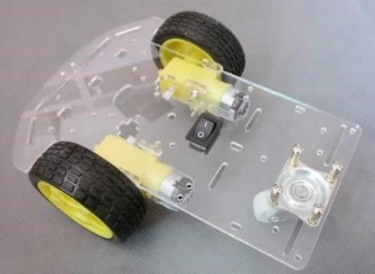

### Figure 6.5 Simple Chassis

A chassis consists of an internal [vehicle frame](https://en.m.wikipedia.org/wiki/Vehicle_frame) that supports an artificial object in its construction and use, can also provide protection for some internal parts. An example of a chassis is the underpart of a [motor vehicle,](https://en.m.wikipedia.org/wiki/Motor_vehicle) consisting of the frame (on which the body is mounted). If the [running gear](https://en.m.wikipedia.org/wiki/Running_gear) such as wheels and transmission, and sometimes even the driver's seat, are included, then the assembly is described as a [rolling chassis.](https://en.m.wikipedia.org/wiki/Rolling_chassis)

**6.6 BREAD BOARD:**

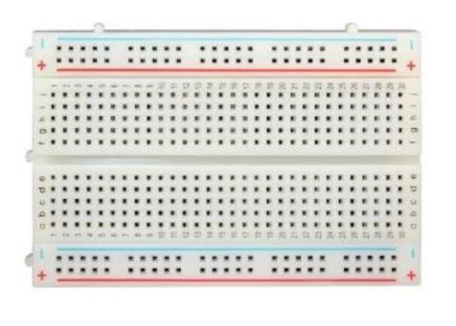

### Figure 6.6 Bread board

A bread board is a contruction base that is meant for a one kind electronic circuit known as prototype.It doesnot require soldering hence it is reusable.This makes it easy to create temporary ones especially when carrying out experiment.

# CHAPTER 7 IMPLEMENTATION AND RESULT

## 7.1 RESULT OBTAINED

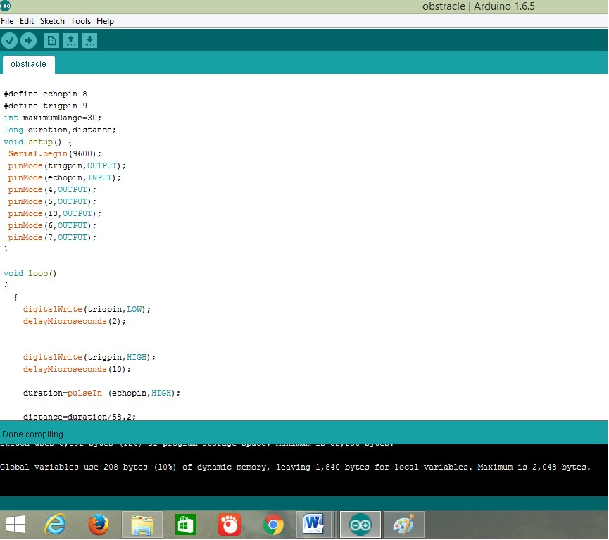

**Figure 7.1 Sample Arduino IDE**

## 7.2 WORKING

Before going to working of the project, it is important to understand how the ultrasonic sensor works. The basic principle behind the working of ultrasonic sensor is as follows:

Using an external trigger signal, the Trig pin on ultrasonic sensor is made logic high for at least 10µs. A sonic burst from the transmitter module is sent. This consists of 8 pulses of 40KHz.

The signals return back after hitting a surface and the receiver detects this signal. The Echo pin is high from the time of sending the signal and receiving it. This time can be converted to distance using appropriate calculations.

The aim of this project is to implement an obstacle avoiding robot using ultrasonic sensor and Arduino. All the connections are made as per the circuit diagram. The working of the project is explained below.

When the robot is powered on, both the motors of the robot will run normally and the robot moves forward. During this time, the ultrasonic sensor continuously calculate the distance between the robot and the reflective surface.

This information is processed by the Arduino. If the distance between the robot and the obstacle is less than 15cm, the Robot stops and scans in left and right directions for new distance using Servo Motor and Ultrasonic Sensor. If the distance towards the left side is more than that of the right side, the robot will prepare for a left turn. But first, it backs up a little bit and then activates the Left Wheel Motor in reversed in direction.

Similarly, if the right distance is more than that of the left distance, the Robot prepares right rotation. This process continues forever and the robot keeps on moving without hitting any obstacle.

# NOTE

* As the project is based on Arduino, the programming is very easy and can be easily modified.
* Doesn’t require the Arduino Motor Shield.
* When using a 9V battery, at least 2 such batteries are needed to power the robot. It is better to use 2 9V batteries (one for Arduino, Ultrasonic sensor, Servo Motor and the other one for L293D and motors).
* The Ultrasonic sensor should not be connected directly to power supply as it might affect the normal performance.
* Instead of ultrasonic sensor, an IR transmitter – receiver pair can also be used.

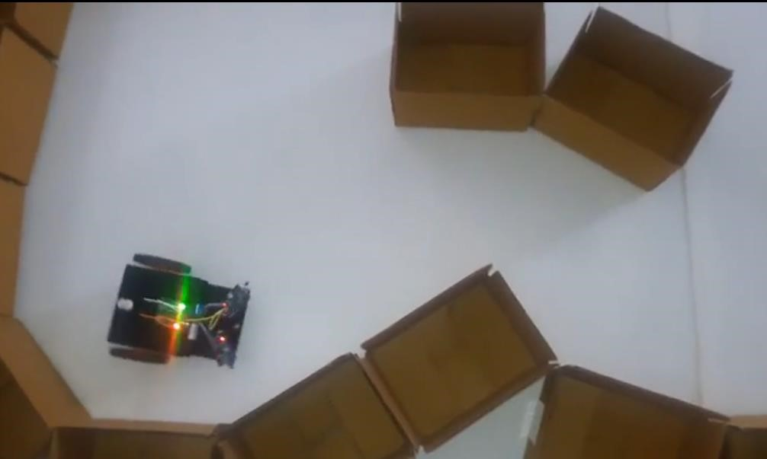

**Figure 7.2 working of obstacle avoidance robot**

# CHAPTER 8 CONCLUSION

.

## 8.1 CONCLUSION

The project “obstacle detection and avoidance robot” is practically proved by using ultrasonic sensor,dc motor which is used for movement of the robot with the help of arduino.This device gives us an opportunity to test mechanical , electronics and programming skills . This project also provides robot construction experience to beginners. This technology is applicable in industry , household appliances etc.

## 8.2 FUTURE ENHANCEMENTS

1.The future work includes the enhancement of the robot design so that it can compute area of a room and plot it on the computer.

2.Adding a camera:If the current project is interfaced with a camera(e.g. a Webcam)robot can be driven beyond line of sight and range becomes practically unlimited as networks have a very large range.

3.Use as a fire fighting robot:By adding temperature sensor,water tank and making some changes in programming we can use this robot as fire fighting robot.

4.we can extend this project with wireless technology by IR or RF or ZIGBEE.

5.We can use the DTMF receiver by using the mobile phone.

6.This robot can be used for pick and place the required object by giving directions to the robot but IR pair should be replaced depending upon the applications.

# REFERENCES

1. Obstacle avoidance robotic vehicle using ultrasonic sensors for obstacle detection <http://www.elprocus.com/obstacle-avoidancerobotic-vehicle/>
2. How to make an obstacle avoiding robot: [http://www.instructables.com/id/How-To-](http://www.instructables.com/id/How-To-Make-anObstacle-Avoiding-Arduino-Robot/)

[Make-anObstacle-Avoiding-Arduino-Robot/](http://www.instructables.com/id/How-To-Make-anObstacle-Avoiding-Arduino-Robot/)

1. IEEE paper for Obstacle avoidance robot using ultrasonic sensors:

[http://www.personal.umich.edu/~ykoren/uploads/O bstacle_avoidance_w_ultrasonic_sensors_IEEE.pdf](http://www.personal.umich.edu/~ykoren/uploads/O%20bstacle_avoidance_w_ultrasonic_sensors_IEEE.pdf) [4]Obstacle avoiding robot without using microcontroller <http://www.roboticsbible.com/project-obstacleavoiding-robot.html>[5]How to build an obstacle avoiding robot:

<https://www.youtube.com/watch?v=JZ5JjvfY1Eg> [6]Complete guide for ultrasonic sensor HC-SR04 tutorials:

http://randomnerdtutorials.com/complete-guide-forultrasonic-ssensor-hc-sr04/ [7] Duino-Robotics(2013 Obstacle Avoidance Tutorial) Retrieved November 23 2015 from <http://www.duinorobotics.com/obstacleavoidance.html>

[8]Gray,K.W.(2000).Obstacle Detection and Avoidance for an Autonomous Farm Tractor.Utah State University

[9]Heidarsson,H.K.,&Sukhatme, G.S.(2011).Obstacle Detection and Avoidance for an Autonomous Surface Vehicle using a Profiling sonar:2011 IEEE International Conference on Robotics and Automation. Shanghai.

[10]Ryther C.A &Madsen,O.B(2009).Obstacle Detection and Avoidance for Mobile Robots.Technical University of Denmark.

[11]Shahdib F. Ullah M.W.Hasan M.K&Mahmud H(2013).Obstacle Detection and Object Size Measurement for Autonomous Mobile Robot using Sensor,International Journal of Computer Application,66(9),28-33.